Lab - 5

Name - Parmar Dhruv  
ID - 202001093

Github repository is ‘<https://github.com/Rapptz/discord.py/tree/master/discord>’

Static Analysis Tool that we used are Mypy and Pylint

**The output of Pylint is**

setup.py:20:0: C0301: Line too long (116/100) (line-too-long)

setup.py:24:0: C0301: Line too long (117/100) (line-too-long)

setup.py:102:0: C0304: Final newline missing (missing-final-newline)

setup.py:1:0: C0114: Missing module docstring (missing-module-docstring)

setup.py:5:5: W1514: Using open without explicitly specifying an encoding (unspecified-encoding)

setup.py:8:0: C0103: Constant name "version" doesn't conform to UPPER_CASE naming style (invalid-name)

setup.py:9:5: W1514: Using open without explicitly specifying an encoding (unspecified-encoding)

setup.py:28:11: W0718: Catching too general exception Exception (broad-exception-caught)

setup.py:20:12: R1732: Consider using 'with' for resource-allocating operations (consider-using-with)

setup.py:31:0: C0103: Constant name "readme" doesn't conform to UPPER_CASE naming style (invalid-name)

setup.py:32:5: W1514: Using open without explicitly specifying an encoding (unspecified-encoding)

setup.py:2:0: C0411: standard import "import re" should be placed before "from setuptools import setup" (wrong-import-order)

setup.py:24:12: R1732: Consider using 'with' for resource-allocating operations (consider-using-with)

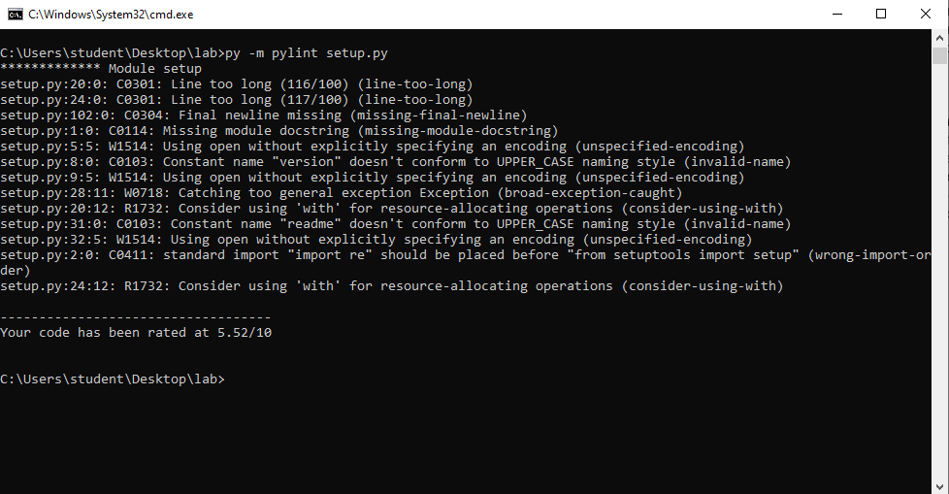

**The explanations of the above error are**

* Line 20 and 24 are too long (more than 100 characters) and those lines should be shortened.
* Line 102 is specifically missing a final newline
* There is no module docstring in the file.
* The open function is used without specifying an encoding on lines 5 and 9.
* In lines 5 and 9, the open function is used without specifying.
* The constant version on line 8 should be written in all uppercase letters to conform to the UPPER_CASE naming style.
* A too general exception is caught on line 28.
* Resource-allocating operations on lines 20 and 24 should be considered using the with statement.
* Constant readme on line 31 should be written in all uppercase letters to conform to the UPPER_CASE naming style.
* The standard import import re on line 2 should be placed before from setuptools import setup on line 1.